San Jose State University

Department of Electrical Engineering

EE250-03
Fall 2017

Midterm 2

Duration: 1 hour

SOLUTION

November 9, 2017

This test consists of four problems.

CLOSED BOOK

Use of one sheet (double sided) of formula is allowed.

Last Name:

First Name:

Student ID:

Problem | Grade
1
2
3
4

Total

Good Luck!

Prof. Kamali

Problem #1 [7 points]: The probability generating function of a discrete random variable is given as follows.

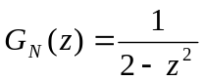 for 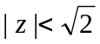

Find the pmf of .

Solution:

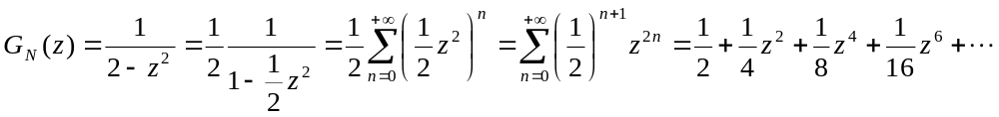
where we have used (equivalently 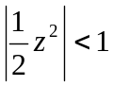). Comparing the above series with the definition of 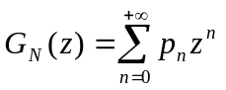, we conclude

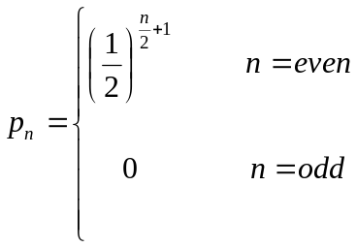

Problem #2 [7 points] The joint pmf of the discrete random pair  is given in the following table. Find 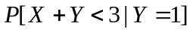.

 | 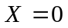 | 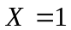 | 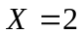 | 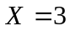
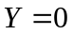 | 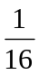 |  | 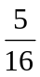 | 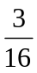
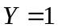 | 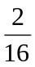 | 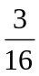

Solution:

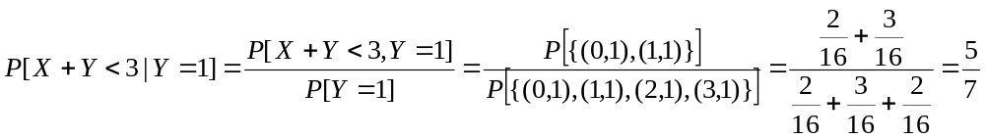

Problem #3 [9 points]: The joint pdf of the random pair is given as follows.

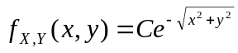 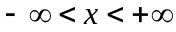, 

- Find .
- Find the probability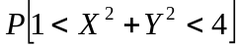.

Solution:
- 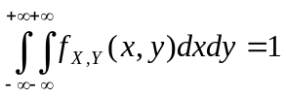

We use polar coordinates to compute the integral as follows.

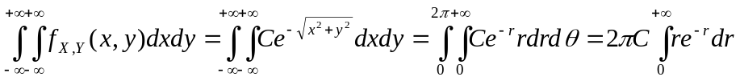
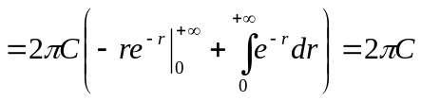

Thus 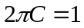and 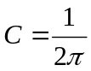.

- 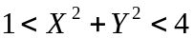 is the area between the two circles with radii 1 and 2 which both have origin as their centers. Again, we use the polar coordinates.

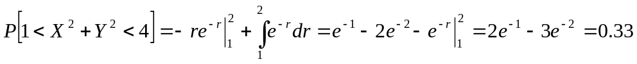

Problem #4 [7 points]: Assume  is an exponential random variable with mean 1 (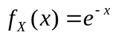for 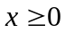) and 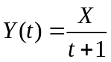 for 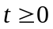. Find the pdf of 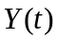.

Solution:

Clearly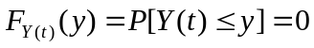 for 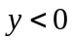.

For  